Photosynthesis and Cellular Respiration
– Understanding the Basics of Bioenergetics and Biosynthesis

This figure summarizes the processes in plant cells that provide the energy for the cells’ biological activities.  First, photosynthesis uses the energy in sunlight to make glucose from carbon dioxide and water.  Then, cellular respiration uses glucose and oxygen as inputs for reactions that provide the energy to make ATP from ADP and P.  Finally, hydrolysis of ATP provides energy in the form needed for many biological processes.  1a. Why do plants need to carry out all three of these processes?  Explanation of why hydrolysis of ATP is needed: | 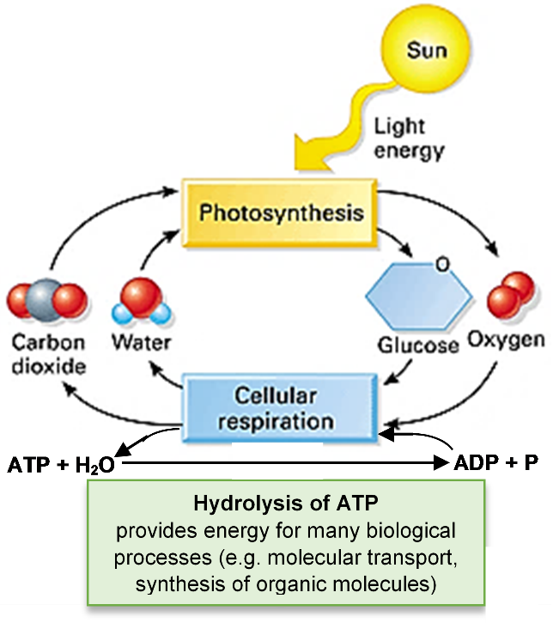

Explanation of why cellular respiration is needed:

Explanation of why photosynthesis is needed:

1b. Why do animals need to carry out cellular respiration and hydrolysis of ATP, but not photosynthesis?

2a. Photosynthesis produces glucose and oxygen which are inputs for _______________________.

2b. Cellular respiration produces carbon dioxide and water which are inputs for _______________.

2c. Photosynthesis and cellular respiration make a cycle where the outputs from each process are inputs for the other process. Draw an oval around the part of the figure that shows this cycle.

3a. Cellular respiration produces ATP and H₂O which are inputs for _________________________.

3b. The hydrolysis of ATP produces ADP and P which are inputs for _________________________.

3c. Cellular respiration and hydrolysis of ATP make a cycle where the outputs from each process are inputs for the other process. Draw a triangle around the part of the figure that shows this cycle.

4. In this figure, mark the two processes that use glucose with *.

Some of the glucose molecules produced by photosynthesis are used as input for cellular respiration to make ATP.

Other glucose molecules are used as input for the chemical reactions that synthesize organic molecules such as the cellulose in plant cell walls or the amino acids in proteins.

5. How does photosynthesis help plant cells make protein?

To make starch or cellulose, many glucose monomers are joined together in a long polymer.  6a. Circle one glucose monomer in each polymer in this figure.  6b. Put a C next to the location of each unlabeled carbon atom in one glucose monomer in cellulose.  Cellulose gives strength to plant cell walls. Starch stores glucose for future use. | 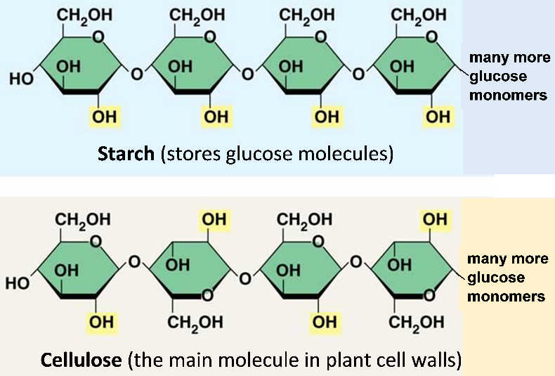

7a. When a seed sprouts, the starch stored in the seed is broken down to glucose which is used by the growing seedling. Give two reasons why the seedling needs glucose.  7b. Does a seedling that is growing underground in the dark  give off CO₂ ___ or take up CO₂ ___? | 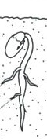

7c. Explain your reasoning.

Plant Growth Puzzle

A plant is made up of water and organic molecules (e.g. cellulose and proteins). Biomass is the weight of the organic molecules in a plant.
Biomass = (a plant’s weight) – (the weight of the water in the plant).

8a. Explain how photosynthesis can increase biomass. Where do the atoms in the added organic molecules come from?

8b. Explain how cellular respiration can decrease biomass. Where do the atoms from the organic molecules go?

A scientist wanted to evaluate the effects of water and light on changes in biomass. She put equal amounts of seeds in petri dishes kept under three different conditions:
- light, no water,
- light and water
- water, no light.
After ten days, the dry seeds had not sprouted, but the seeds that were exposed to water had sprouted to produce small plants. To determine the biomass of each batch of seeds/plants, they were dried in an oven overnight (to remove all the water) and then weighed.

9. For each condition, circle the appropriate arrow to predict the change in biomass after ten days. Explain why you predict a decrease (↓), no change (→), or increase (↑) in biomass.

Condition for each batch of seeds | Light, no water  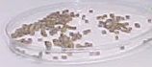  (seeds didn’t  sprout) | 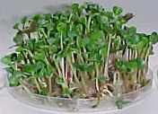  Light, water  (seeds  sprouted) | Water, no light  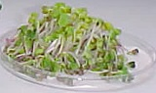  (seeds  sprouted)
Predicted change in biomass | ↓ → ↑ | ↓ → ↑ | ↓ → ↑
Reason for predicting decrease, no change, or increase in biomass

10a. Your teacher will tell you the biomass observed after 10 days in each condition. Enter these observed results in this table.
10b. At the beginning of the experiment, each batch of seeds had approximately 1.46 g of biomass. For each condition, circle the arrow that represents the observed change in biomass.
10c. If any of the observed results differ from your predictions in question 9, explain the biological reasons for the observed results.

Condition for each batch of seeds | Light, no water  (seeds did not sprout) | Light, water  (seeds sprouted to  produce plants) | Water, no light  (seeds sprouted to  produce plants)
Observed biomass at 10 days (grams)
Observed change in biomass | ↓ → ↑ | ↓ → ↑ | ↓ → ↑
If any result did not match your prediction, explain a possible reason for the observed result.

The figure below summarizes a paradoxical result. After 10 days, the dry seeds had the lowest total mass, but the plants that developed in the dark had the lowest biomass.
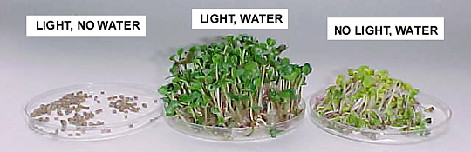
Light, water
Water, no light →
lowest biomass
Light, no water →
lowest volume and
lowest total mass

11. Explain why the plants that developed in the dark had more total mass, but less biomass than the dry seeds. (Hint: About three-quarters of the total mass of a growing plant is water.)

Bonus Question
Suggest a hypothesis to explain why the plants that grew in light had dark green leaves, while the plants that grew in the dark had light green leaves.

By Dr. Ingrid Waldron, Department of Biology, University of Pennsylvania, © 2021. Teachers are encouraged to copy this Student Handout for classroom use. This Student Handout and Teacher Notes with background information and instructional suggestions are available at https://serendipstudio.org/exchange/bioactivities/photocellrespir.

